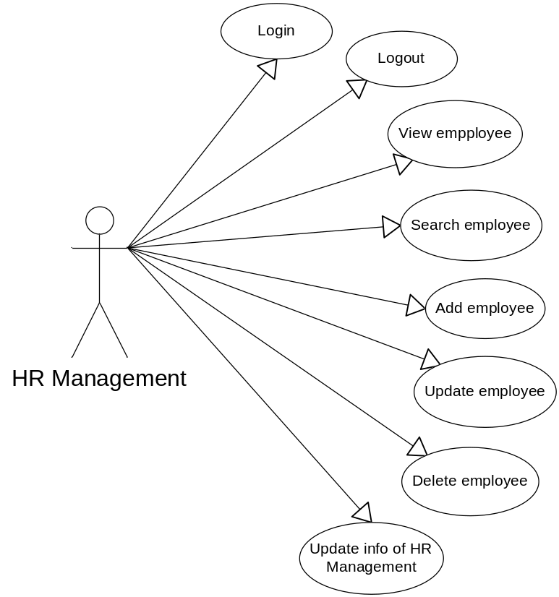

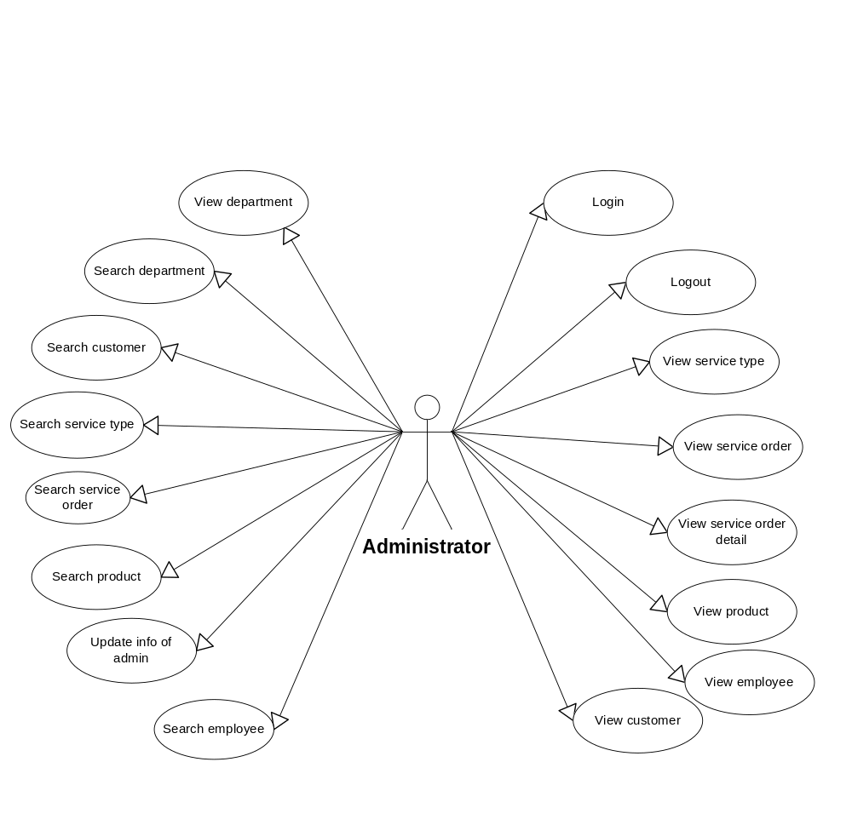

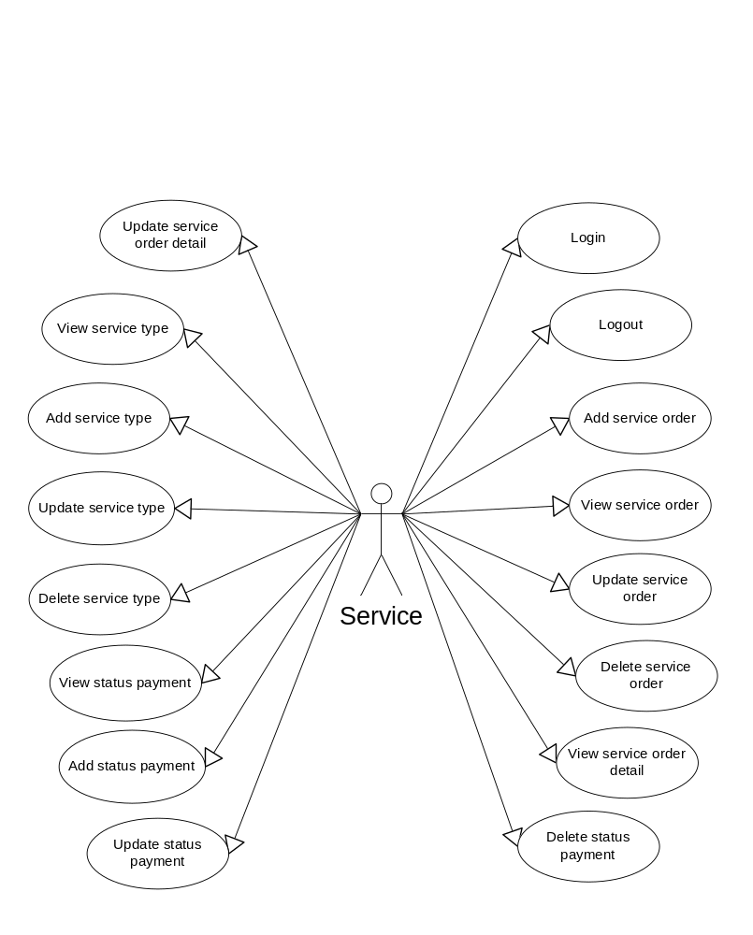
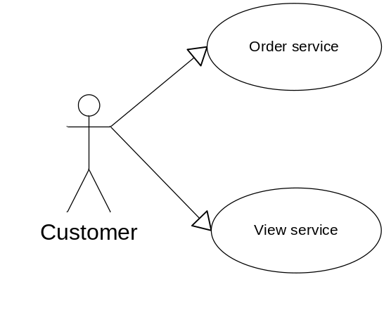
List of Actors
No. | Actors | Comment
01 | HR Management | Human Resource Management
02 | Administration | Management staff and customers
03 | Service | Management
04 | Customer | Order service & View Service

List of Use-Case
No. | Use-Case | Comment
01 | - Login | Users logged into the system
02 | - Logout | Users exit the system
03 | - View empployee
04 | - Search employee
05 | - Add employee
06 | - Update employee
07 | - Delete employee
08 | - Update info of HR Management
09 | - View service type
10 | - View service order
11 | - View service order detail
12 | - View product
13 | - View employee
14 | - View customer
15 | - View deparment
16 | - Search department
17 | - Search customer
18 | - Search service type
19 | - Search product
20 | - Search employee
21 | - Search service order
22 | - Update info of admin
23 | - View service order
24 | - Add service order
25 | - Update service order
26 | - Delete service order
27 | - View service order detail
28 | - Update service order detail
29 | - View service type
30 | - Add service type
31 | - Update service type
32 | - Delete service type
33 | - View status payment
34 | - Add status payment
35 | - Update status payment
36 | - Delete status payment
37 | - Order service
38 | - View service

